The first Industrial Revolution

In the period 1760 to 1830 the Industrial Revolution was largely confined to Britain. Aware of their head start, the British forbade the export of machinery, skilled workers, and manufacturing techniques. The British monopoly could not last forever, especially since some Britons saw profitable industrial opportunities abroad, while continental European businessmen sought to lure British know-how to their countries. Two Englishmen, William and John Cockerill, brought the Industrial Revolution to Belgium by developing machine shops at Liège (c. 1807), and Belgium became the first country in continental Europe to be transformed economically. Like its British progenitor, the Belgian Industrial Revolution centered in iron, coal, and textiles.

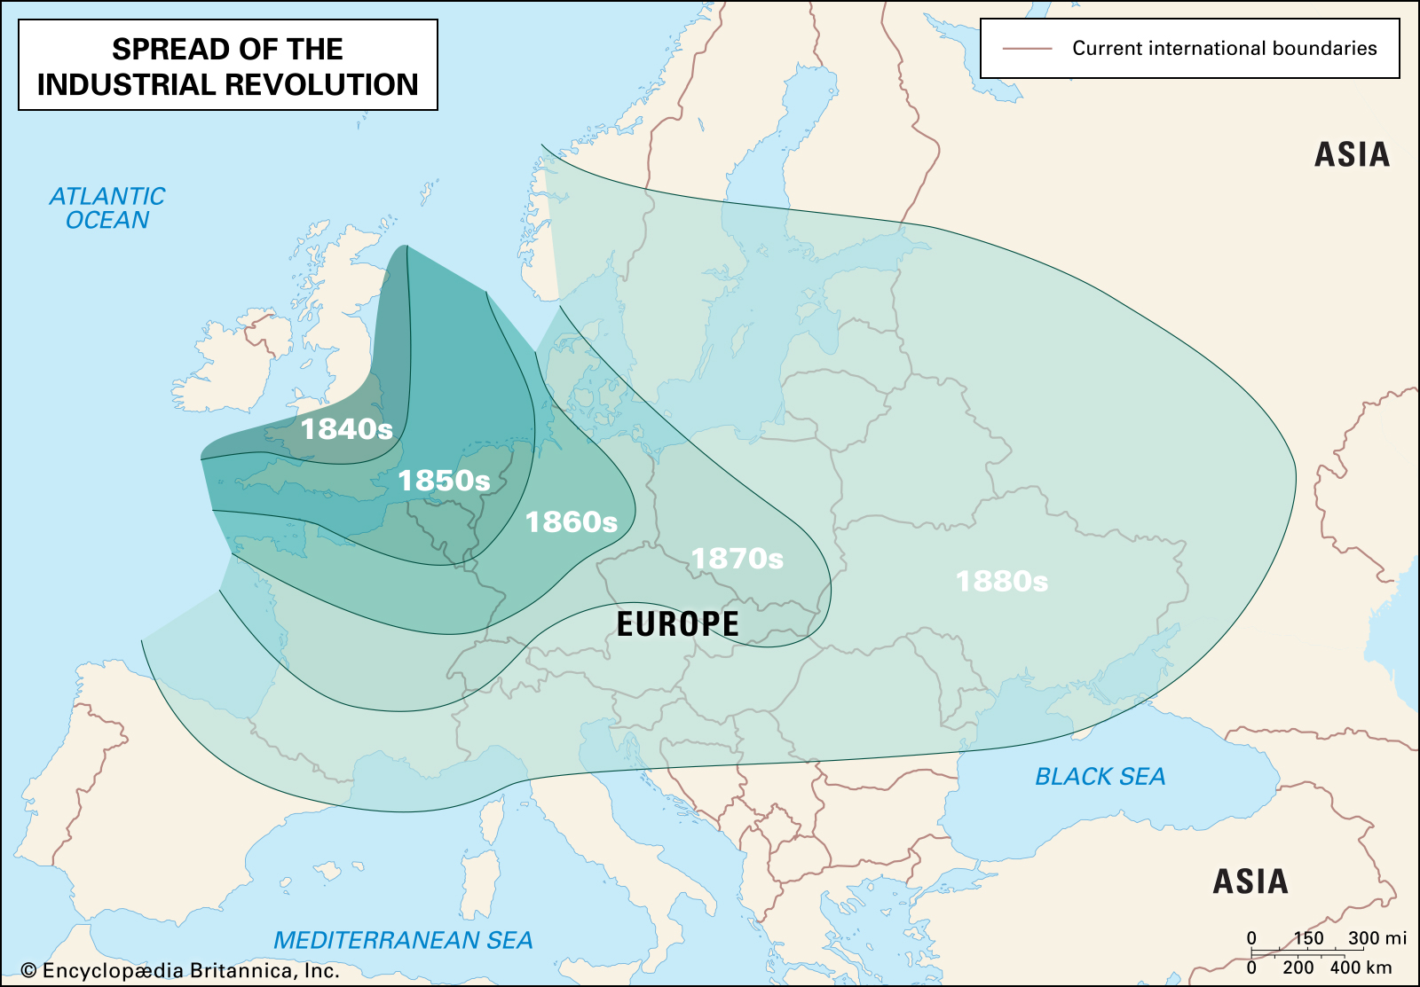
Industrial Revolution – A map depicting the spread of the Industrial Revolution through Europe in the 19th century.
Encyclopædia Britannica, Inc./Kenny Chmielewski

France was more slowly and less thoroughly industrialized than either Britain or Belgium. While Britain was establishing its industrial leadership, France was immersed in its Revolution, and the uncertain political situation discouraged large investments in industrial innovations. By 1848 France had become an industrial power, but, despite great growth under the Second Empire, it remained behind Britain.
Other European countries lagged far behind. Their bourgeoisie lacked the wealth, power, and opportunities of their British, French, and Belgian counterparts. Political conditions in the other nations also hindered industrial expansion. Germany, for example, despite vast resources of coal and iron, did not begin its industrial expansion until after national unity was achieved in 1870. Once begun, Germany’s industrial production grew so rapidly that by the turn of the century that nation was outproducing Britain in steel and had become the world leader in the chemical industries. The rise of U.S. industrial power in the 19th and 20th centuries also far outstripped European efforts. And Japan too joined the Industrial Revolution with striking success.
The eastern European countries were behind early in the 20th century. It was not until the five-year plans that the Soviet Union became a major industrial power, telescoping into a few decades the industrialization that had taken a century and a half in Britain. The mid-20th century witnessed the spread of the Industrial Revolution into hitherto nonindustrialized areas such as China and India.

Source: Encyclopaedia Britannica – visited 11/11 2020 ( https://www.britannica.com/event/Industrial-Revolution )

