ITALY
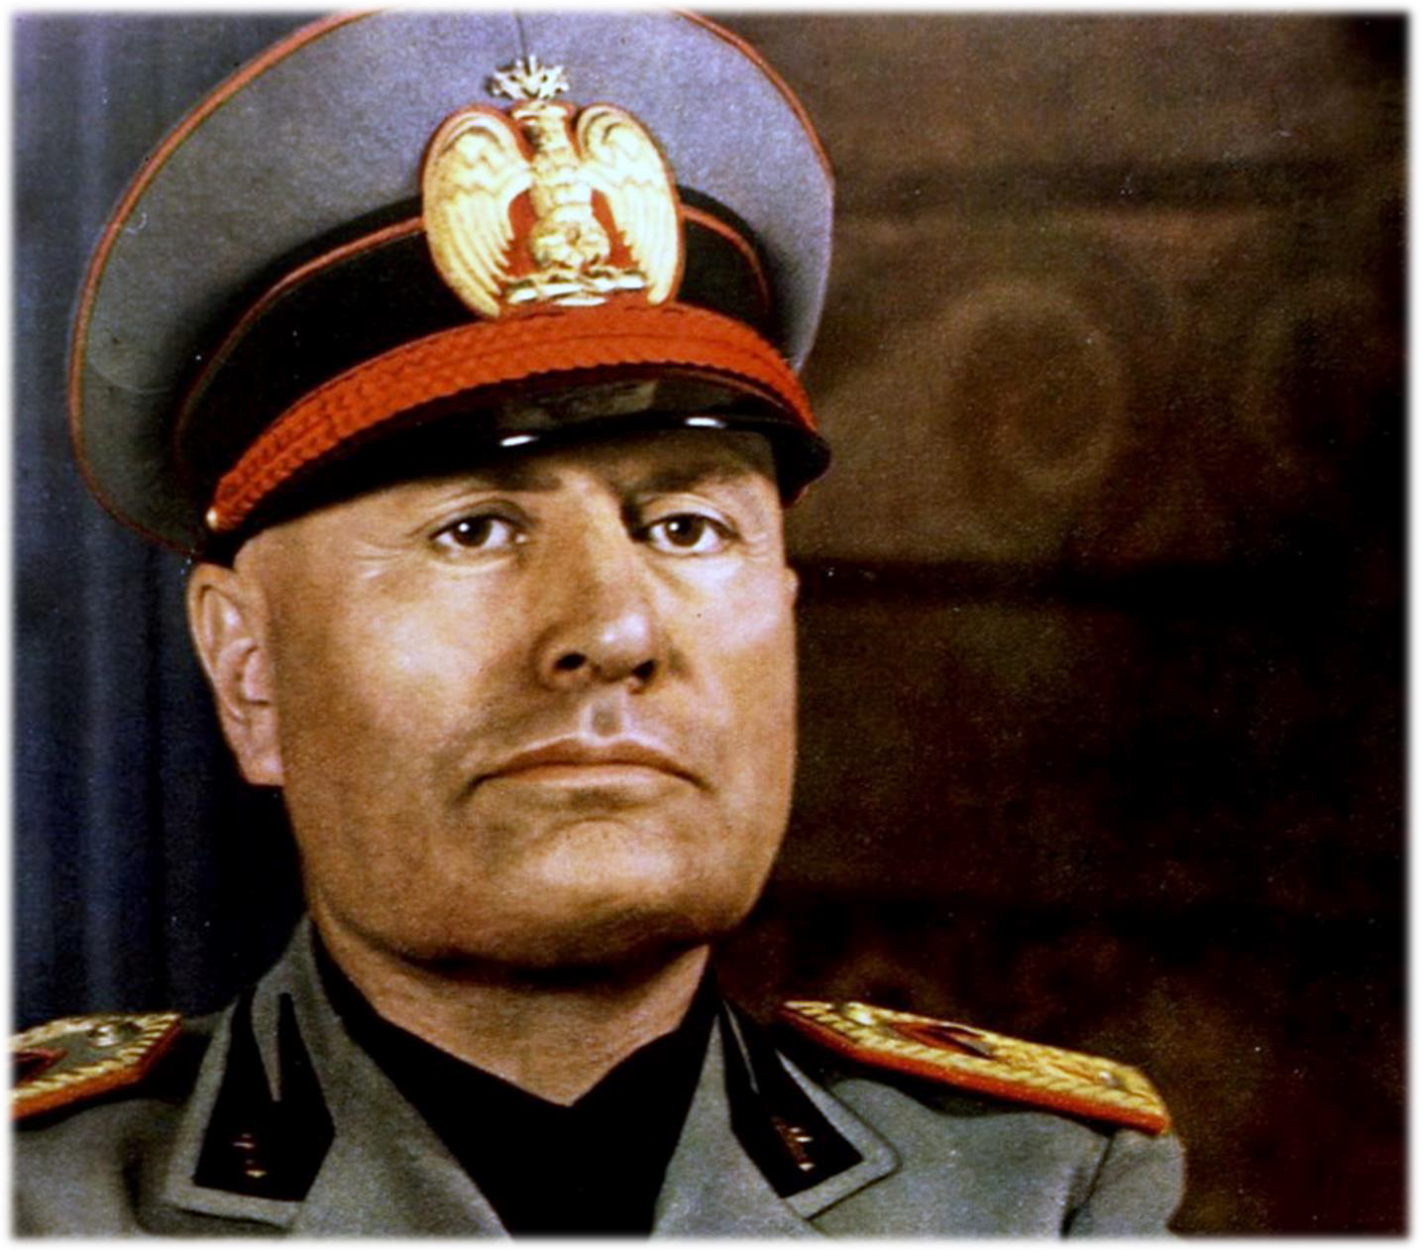
AUTHORITARIAN STATE
MUSSOLINI

AUTHORITARIAN STATES EMERGENCE OF AUTHORITARIAN STATES

COUNTRY: ITALY – MUSSOLINI

CONDITIONS – ECONOMY

CONDITIONS – SOCIAL DIVISION

CONDITIONS – IMPACT OF WAR

CONDITIONS – WEAKNESS OF POLITICAL SYSTEM

METHODS – PERSUATION AND COERSION

METHODS – ROLE OF LEADERS

METHODS – ROLE OF IDEOLOGY

METHODS – USE OF FORCE

METHODS – PROPAGANDA

AUTHORITARIAN STATES CONSOLIDATION AND MAINTENANCE OF POWER

COUNTRY: ITALY – MUSSOLINI

USE OF LEGAL METHODS

USE OF FORCE

CHARISMATIC LEADERSHIP

DISSEMINATION OF PROPAGANDA

NATURE, EXTENT AND TREATMENT OF OPPOSITION

MAINTENANCE: IMPACT OF SUCCESS AND/OR FAILURE OF FOREIGN POLICY ON THE MAINTENANCE OF POWER

AUTHORITARIAN STATES AIMS AND RESULTS OF POLICIES

COUNTRY: ITALY – MUSSOLINI

AIMS AND IMPACT: DOMESTIC ECONOMIC POLICIES

AIMS AND IMPACT: DOMESTIC POLITICAL POLICIES

AIMS AND IMPACT: DOMESTIC CULTURAL POLICIES

AIMS AND IMPACT: DOMESTIC SOCIAL POLICIES

IMPACT OF POLICIES: WOMEN

IMPACT OF POLICIES: MINORITIES

AUTHORITARIAN CONTROL: METHODS

AUTHORITARIAN CONTROL: ACHIEVEMENT

